**FOR IMMEDIATE RELEASE**

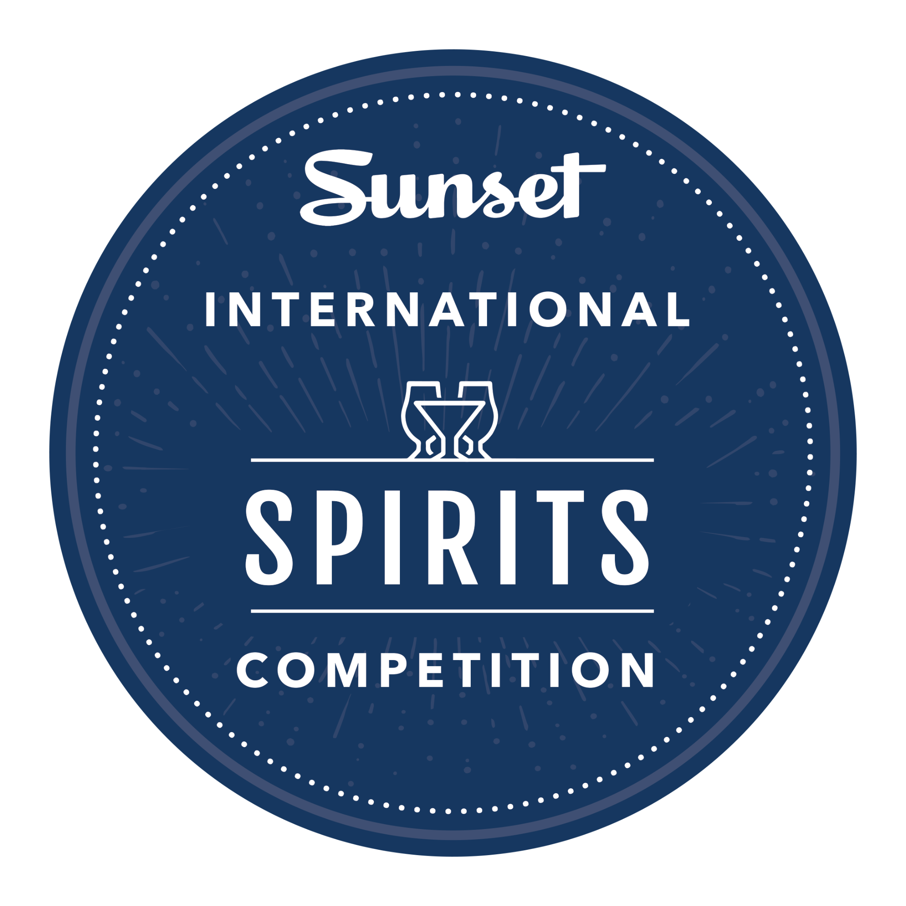

**2024 SUNSET INTERNATIONAL SPIRITS COMPETITION ANNOUNCES WINNERS**

**HERITAGE BUSHMILLS BRAND TAKES TOP HONORS**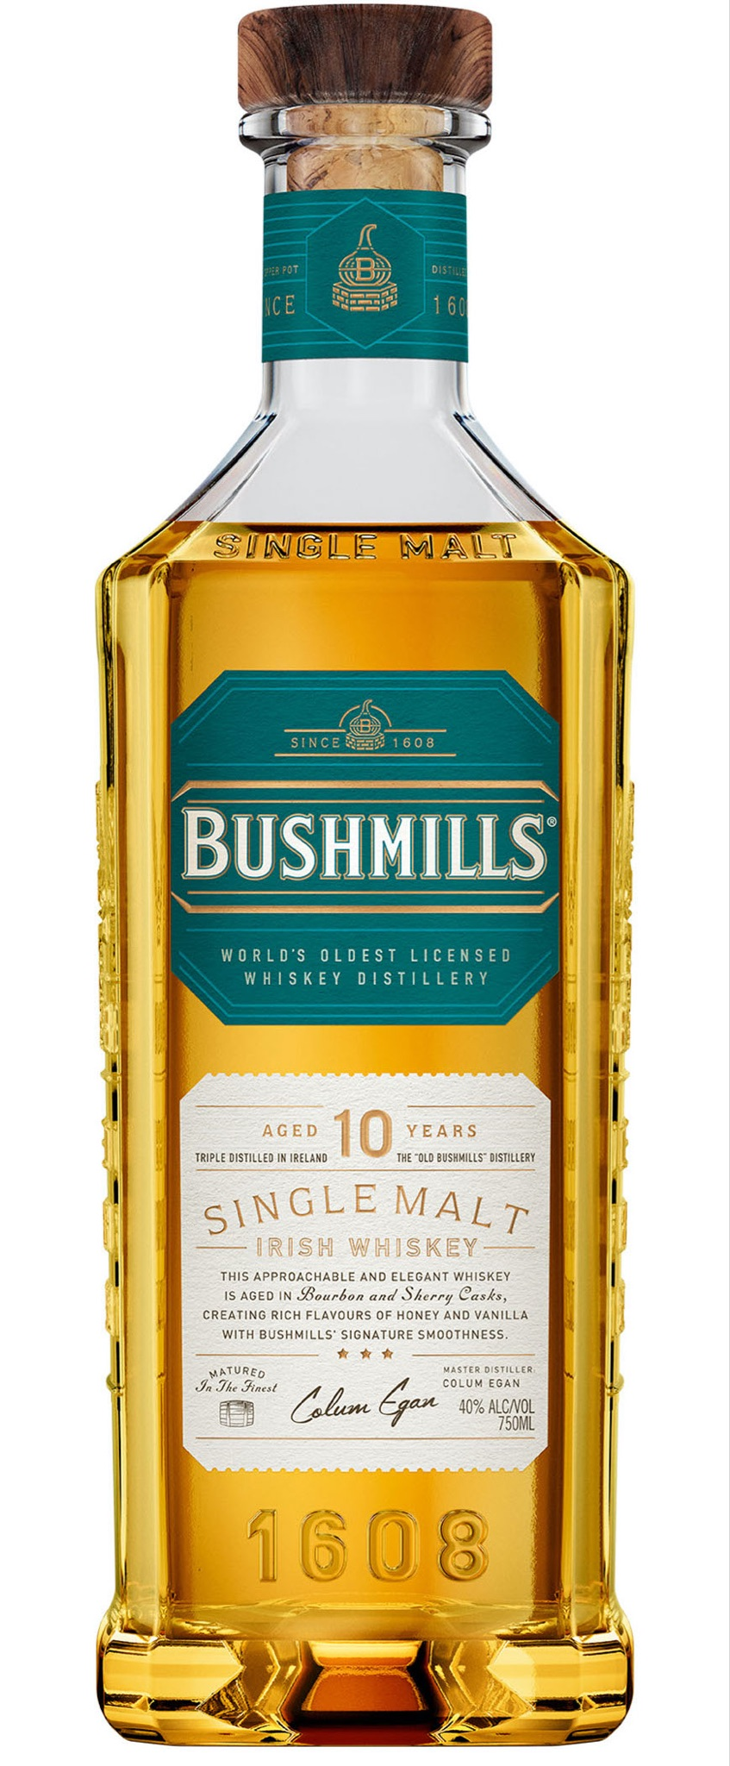

**SANTA ROSA, CALIF.** – Winners have been announced in the 2024 Sunset International Spirits Competition. This year’s winner is a stellar entry from a heritage brand. After a full day of tasting and discussion, Bushmills’ 10-year-old single malt Irish Whiskey took top honors. Judges described its “Sugar, rich malt, citrus” and “earthy and peaty quality.” One judge declared it “Has a WOW factor.”

Granted a license to distill in 1608, Bushmills is the oldest licensed whiskey distillery in the world. Bushmills Single Malt Whiskey 10-year-old is triple distilled from 100% malted barley and matured in former sherry casks and bourbon-seasoned casks. The delectable libation was named Best of the Best, Best Whiskey and Best Irish Whiskey, and awarded 98 points.

Other medal winners included products from across the globe, including Switzerland, Canada, Spain and multiple U.S. states. “I continue to be impressed by the wide breadth of competitors, year after year,” says Debra Del Fiorentino, owner of Wine Competitions Management at Production, which oversees the Sunset International Spirits Competition. “As word gets out about this prestigious event, we have more interest — and entries — from around the world. It’s a testament to the reputation Sunset has established as a style leader and lifestyle brand.”

Now in its sixth year, the Sunset International Spirits Competition is open to commercial distillers of all sizes, with judging categories based on spirit type, production techniques and price points. Winning producers will be featured in a Spring release of a Spirits Special non-print, digital edition with supporting microsite. Promotions for the Spirits Award Special Issue will be placed in sunset.com, Sunset eNewsletters and Sunset social sites. The edition will be promoted and available for 12 months or until the 2025 Spirit Awards winners are announced.

*View a full list of winners here:* [*sunsetcompetitions.com/sunset-international-spirits-competition/*](https://sunsetcompetitions.com/sunset-international-spirits-competition/)

**2024 Sunset International Spirits Competition**

**Best of Class Awards**

**Best of the Best, Best Whiskey, Best Irish Whiskey, Best of Class**

Bushmills 10-year-old Single Malt Irish Whiskey (BOC, GG, 98 pts.)

Judges: “Sugar, rich malt, citrus”; “earthy and peaty quality”; “Has a WOW factor.”

**Best Vodka**

The Community Spirit Vodka (BOC, GG, 95)

Judges: “Herbaceous, soft”; “Easy to drink”; “Pleasant.”

**Best Vodka-Infused**

Tin City Distillery Chocolate Love Vodka (BOC, G, 92)

Judges: “Mild chocolate aroma”; “Taste of caramel and chocolate.”

**Best Gin**

Stillweather Spirits American Sunset Gin (BOC, GG, 97)

Judges: “Kefir and lime”; “Wonderful botanicals”; “Complex. Good layers.”

**Best Akvavit**

Vice & Vertu Distilleries AquaVice (BOC, GG, 98)

Judges: “Lemon, fennel, coriander and juniper”; “Very complex.”

**Best Sake**

Soto Junmai Daiginjo (BOC, GG, 96)

Judges: “Spice and personality”; “Nice, rich character.”

**Best Tequila, Best Reposado Tequila**

1800 Reposado (BOC, GG, 96)

Judges: “Ripe, lively”; “Caramel”; “Layered and complex.”

**Best Blanco Tequila**

Lobos 1707 Tequila (BOC, GG, 98)

Judges: “Smooth”; “Great sipper”; “Elegant and classy.”

**Best Cristalino**

1800 Cristalino (Añejo) (BOC, GG, 97)

Judges: “Elegant”; “Refined”; “Lingering finish.”

**Best Añejo Tequila**

1800 Anejo (BOC, GG, 98)

Judges: “Elegant”; “Mexican baking chocolate”; Savory, layered.”

**Best Extra Añejo Tequila**

1800 Milenio (BOC, G, 94)

Judges: “Earthy, dry”; Elegant finish.”

**Best Mezcal**

400 Conejos Reposado (BOC, GG, 96)

Judges: “Bright and clean, aromatically”; “Great example of Mezcal”; “Nice oak flavor.”

**Best Canadian Whiskey**

Pendleton Original (BOC, GG, 95)

Judges: “Caramel, vanilla, sweet edges”; “Citrus”; “Classic Canadian whiskey.”

**Best Small Batch Whiskey**

Redwood Empire Whiskey Van Duzen (BOC, GG, 97)

Judges: “Mellow”; “Granola to maple sugar and banana foster.”

**Best Single Malt Whiskey**

Saentis Malt - Swiss Alpine Whisky (BOC, GG, 98)

Judges: “Fennel, natural sugar, root vegetable and roasted pumpkin.”

**Best Bourbon**

CALI Thunder Mesquite-Finished Bourbon (BOC, GG, 95)

Judges: “Sweet maple palate with mesquite on the nose”; “Clean.”

**Best Straight Rye**

High West Distillery Double Rye (BOC, G, 94)

Judges: “Sweet, buttery oatmeal on palate”; “Nice warm spice: nutmeg, a little ginger and cardamom.”

**Best Single Barrel Whiskey**

Uncle Nearest Single Barrel Whiskey - Batch 905 (BOC, GG, 95)

Judges: “Sweet oak with vanilla”; “Spicy, vibrant and energetic.”

**Best Tennessee Whiskey**

Uncle Nearest 1856 Premium Aged Whiskey (BOC, GG, 95)

Judges: “Lovely”; “A damn good glass”; “Nice honey taste.”

**Best Rum**

Ron del Barrilito 5 Stars Rum (BOC, GG, 99)

Judges: “Honeyed mouthfeel”; “Subtle and classic”; “Chocolate raisins”; “Savory finish.”

**Best Brandy**

Korbel Champagne Cellars Classic Brandy (BOC, G, 94)

Judges: “Astounding technique”; “Lovely, wonderful fruit”; “Easy finish.”

**Best Liqueur**

Two Stacks Double Irish Cream Liqueur (BOC, G, 92)

Judges: “Easy sipper”; “Very elegant”; “Well integrated.”

**Best Ready to Drink (RTD)**

Salt Point Vodka Mule Canned Vodka Cocktail (BOC, GG, 95)

Judges: “Ginger forward”; “Long finish”; “Refreshing.”

**Best Hard Seltzer**

High Noon Tequila Lime (BOC, G, 92)

Judges: “Hint of lime and mineral”; “Clean and well made”; “Delicious and refreshing.”

**Best Cannabis-Infused**

Nowadays Canned THC Cocktail, Berry (BOC, G, 91)

Judges: “Berries upfront”; “Pops mid-palate”; “Nice finish. Refreshing.”

**Best Mixer**

Tommy's Margarita Mix - Jalapeno (BOC, GG, 95)

Judges: “Well balanced and pronounced”; “ Crisp, clean, excellent.”

**—END—**